Regulations:
A17

H.T No

Sreenidhi Institute of Science and Technology
(An Autonomous Institution)
Code No: 6A242 Date: 31-May-2018 (FN)

B.Tech I-Year II-Semester External Examination, May/June - 2018 (Regular)
NETWORK ANALYSIS (ECE & ECM)

Time: 3 Hours Max.Marks:75

Note: a) No additional answer sheets will be provided.
b) All sub-parts of a question must be answered at one place only, otherwise it will not be valued.
c) Missing data can be assumed suitably.

Part - A Max.Marks:25

Answer all QUESTIONS.

1. | What is the voltage across 10Ω resistor for the circuit shown in the below figure?  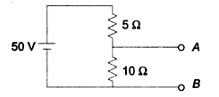 | [3M]
2. | Define (i) Resonance, (ii) Band Width (iii) Quality Factor | [3M]
3. | Two identical coupled coils have an equivalent inductance of 60mH when connected in series aiding and 30mH in series opposing. Find L₁, L₂ and K. | [3M]
4. | Write the statement of Maximum Power Transfer theorem. | [3M]
5. | Write down the condition for Reciprocity and symmetry in h-parameter network. | [3M]
6. | Differentiate between transient and steady state responses. | [2M]
7. | Define Peak factor and Form factor. | [2M]
8. | Compare the analogy of magnetic circuits and electric circuits. | [2M]
9. | Obtain the time constant for a series R-L circuit having R = 2Ω and L= 10H while a DC voltage of 100V is applied. | [2M]
10. | State Reciprocity theorem with DC excitation. | [2M]
Part – B Max.Marks:50
ANSWER ANY FIVE QUESTIONS. EACH QUESTION CARRIES 10 MARKS.

11. | a) | For the circuit shown in the below figure.  Calculate: i) Impedance ii) Total current iii) Phase angle.  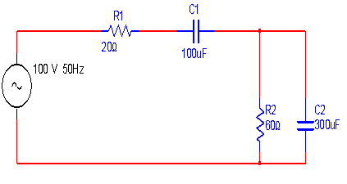 | [6M]
 | b) | Write the differences between series resonance and parallel resonance. | [4M]
12. | a) | What is meant by dot convention? Derive an expression for equivalent inductance when two coils are connected in series opposing. | [4M]
 | b) | An iron ring of 20cm in diameter and 15cm² in area of cross section is wound with coil of 400 turns. Find the current in the coil to establish a flux density of 1.5wb/m², If the relative permeability of iron is 800. In case if an air gap of 2.5mm is cut in the ring, what is the current in the coil to establish the same flux density? Neglect leakage flux. | [6M]
13. | a) | Find the current delivered by the source for the network shown in figure using  Network reduction technique.  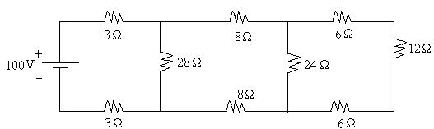 | [5M]
13. | b) | Find the current supplied by 12V Battery by using Star - Delta transformation for the following network.  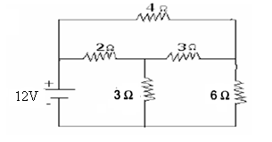 | [5M]
14. | a) | Calculate the current in the 2Ω resistor of the below circuit using superposition theorem.  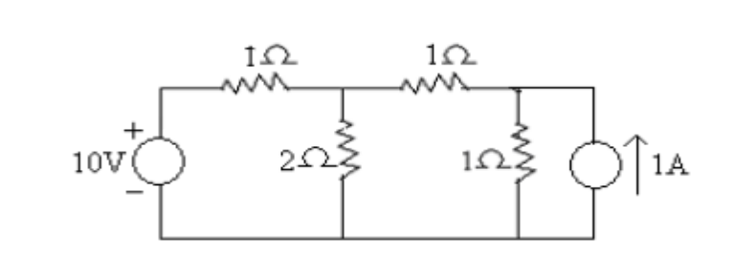 | [6M]
 | b) | Find current in R_{L} of the following circuit using Thevinin’s theorem.  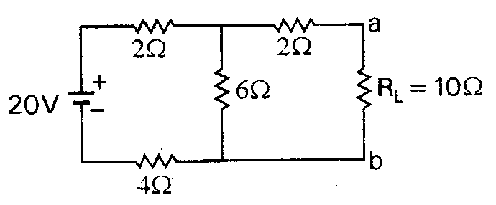 | [4M]
15. | a) | Obtain Y-parameters of the below circuit.  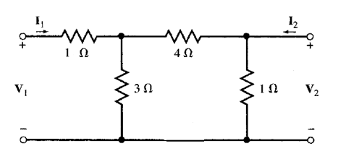 | [6M]
 | b) | Obtain ABCD-parameters in terms of Z-parameters. | [4M]
16. | a) | Derive an expression for transient response of R-C series circuit with DC excitation using Differential equation method. | [4M]
 | b) | In the following circuit the switch is closed at t=0. Obtain the currents i₁(t) and i₂(t) for t > 0 in time domain.  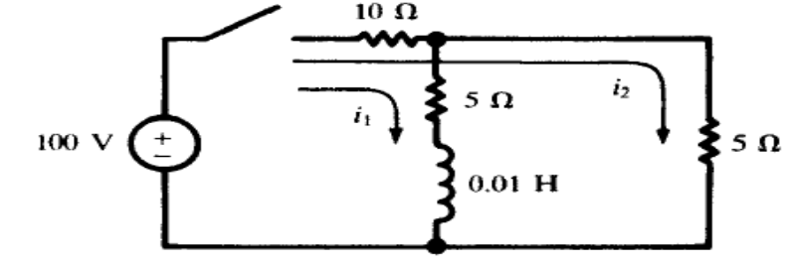 | [6M]
17. | a) | Distinguish between Independent and dependent, ideal and practical Sources. | [3M]
 | b) | Derive an expression for current in an ac circuit consisting of pure capacitance and also draw the phasor diagram. | [4M]
 | c) | State and explain Faraday’s laws of electromagnetic induction. | [3M]
18. | a) | Is Nortons theorem dual of Thevenin’s theorem? Justify your answer. | [3M]
 | b) | Show that when two 2-port networks N₁ and N₂ are connected in parallel, then the equivalent Y-parameters of the combined network is the sum of Y-parameters of each individual 2-port networks. | [3M]
 | c) | Derive an expression for transient response of R-L series circuit with DC excitation using Laplace transform method. | [4M]
-- 00 -- 00 –

